Soft Glass Bead Making
Garret Oaks
goaks@coloradocollege.edu

Congratulations on taking the first step towards an exciting adventure into the world of glass! Although glass can be tons of fun, it does present some interesting challenges when it comes to handling and working with hot glass.
- Glass gets HOT!! A gas torch is used to shape the glass at over 1,000 F.
- Glass can be SHARP!! A key trait of glass.
- You will exert yourself physically. The glass is shaped holding your arms up in front of you. Please consider your abilities.
- Please wear studio appropriate clothing.
There are two main purchases that are required for this course:
- The Fireworks Beginner’s Essentials Glass Beadmaking Kit
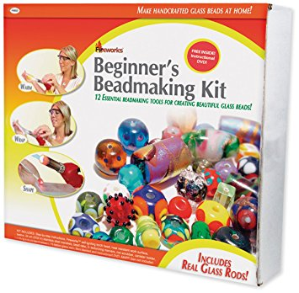
- MAP/P Gas Canister
The Fireworks Beginner’s Essentials Glass Beadmaking Kit is required for this course. You may purchase this from Hobby Lobby both in store and on-line. The kit is regularly priced at $119.99 but the 40% off coupon available for both in-store and on-line purchases reduces the cost to $71.99 before tax or shipping. Please call first to check availability when purchasing from the store. This kit will include:
1 - Quick-Light Self-Igniting Torch
12 – Mandrels
1 - Bead Rake
1 - Dotted Texturizing Marver
1 - Grooved Texturizing Marver
1 - Rod Scrubber
2 - 14" x 17" Heat-Resistant Work Surfaces
1 - Canister Holder
1 - Diamond Coated Bead Reamer
1 - Pair Safety Glasses
1 4-Ounce Bead Release
15 - Italian Glass Rods
1 - Fiber Blanket
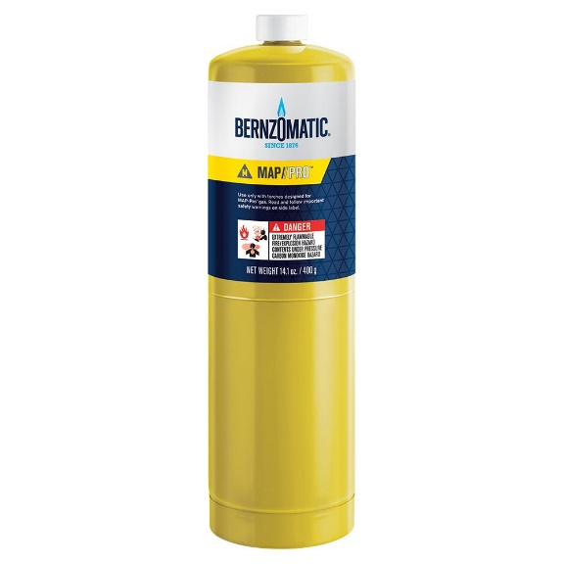
The canister of MAP/P Gas can be purchased from a number of locations to include Home Depot, Lowes, ACE Hardware…and cost roughly $11.00.
If you have any questions please contact the instructor, Garret Oaks, by email at goaks@coloradocollege.edu. Or by phone at 720-684-7718

